**Introduction - This research program focuses on cultural publics in the era of network society.**

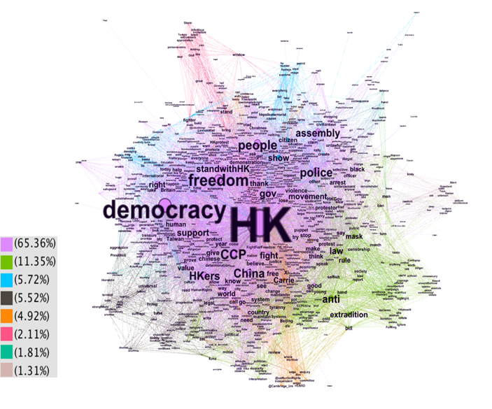

The formation of publics has been re-written by the mediation of information and communication technologies in the era of network society. Cultural publics originated from popular culture fans and celebrities have increasingly taken the center stage of active citizenship. Shared among the diverse groups of nowadays cultural publics are the rooting in cultural identity, and the shaping role played by new media. The logic behind algorithm-driven traffic media, the financial move made by new media companies, and the user communities’ negotiation present a complex web of actors in contesting cultural publics.

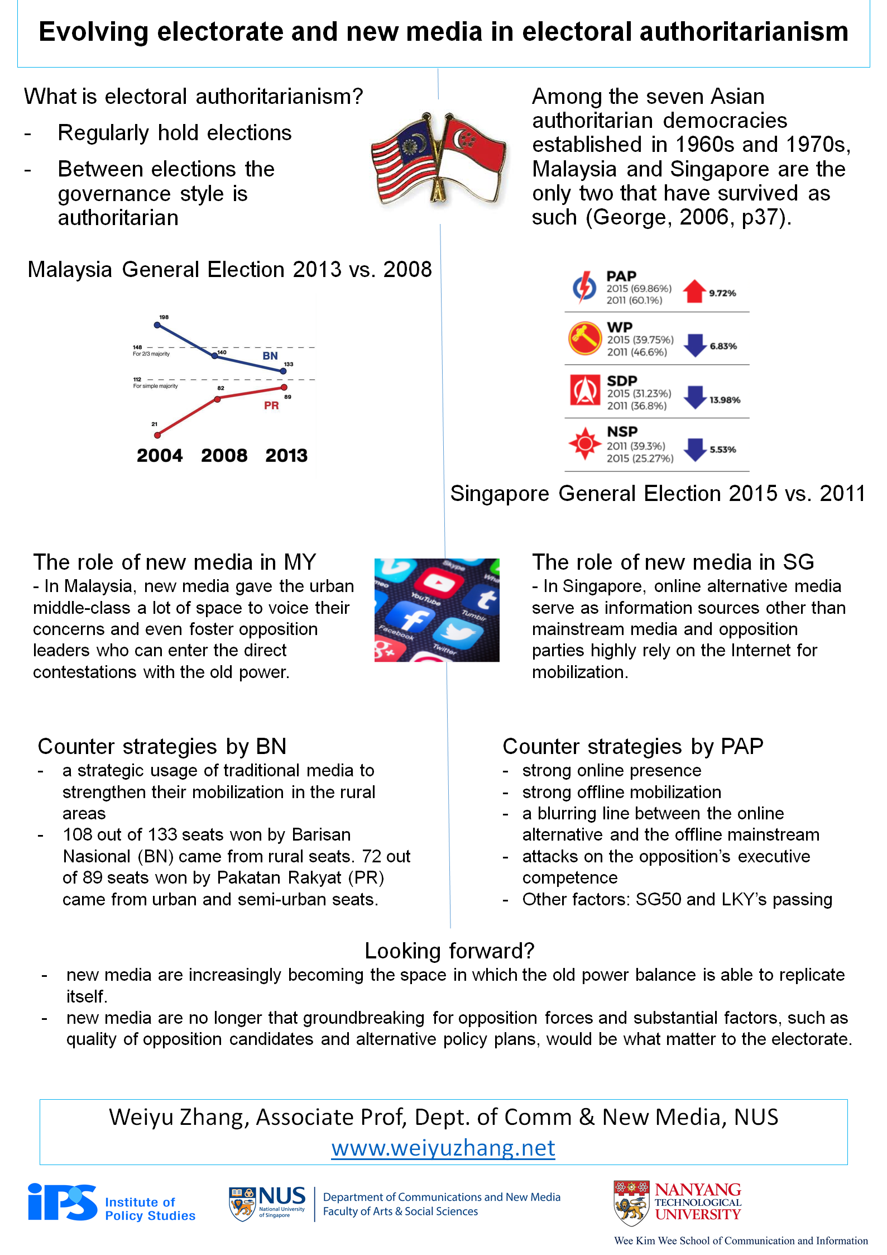

Political culture varies among countries, due to their unique AND interwoven historical trajectories. Public engagement in activities such as political talk, elections, protests must be understood within the time- and location-bounded contexts. Historically, authoritarian orientation is salient in some countries than others; elections are indigenous to some cultures but imported to others; participatory acts, either online or offline, contain widely different meanings. The influence of political culture, even in a digital age, is best made evident if we take a comparative approach to examine the South against the South.

Collaborators

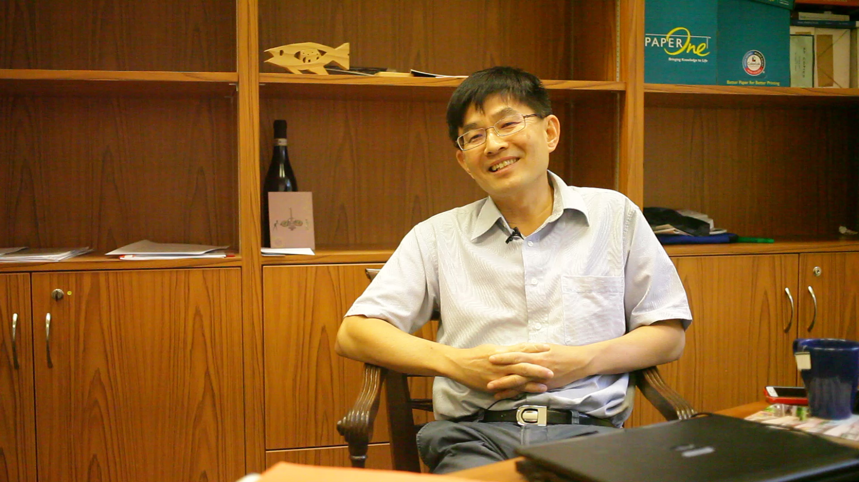

[Tan Tarn How](https://lkyspp.nus.edu.sg/ips/about-us/staff-directory/tan-tarn-how)

PI; Adjunct Senior Research Fellow, Institute of Policy Studies, NUS



[Dr. Carol Soon](https://lkyspp.nus.edu.sg/ips/about-us/staff-directory/soon-carol)

PI; Senior Research Fellow, Institute of Policy Studies, NUS



[Dr. Natalie Pang](https://discovery.nus.edu.sg/11678-lee-san-natalie-pang)

Co-PI; Senior Lecturer, CNM, NUS

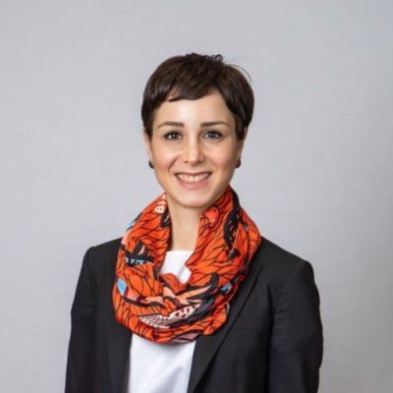

[Dr. Gulizar Haciyakupoglu](https://www.rsis.edu.sg/profile/gulizar-haciyakupoglu/)

PhD Graduate, 2016; currently ***Research Fellow at Nanyang Technological University***



[Dr. Kecheng Fang](http://www.fangkc.com/)

Collaborator; currently Assistant Professor, Chinese University of Hong Kong



[Dr. Chengting Mao](http://faculty.hitsz.edu.cn/maochengting)

Research Assistant; currently Assistant Professor, Harbin Institute of Technology (Shenzhen Campus)

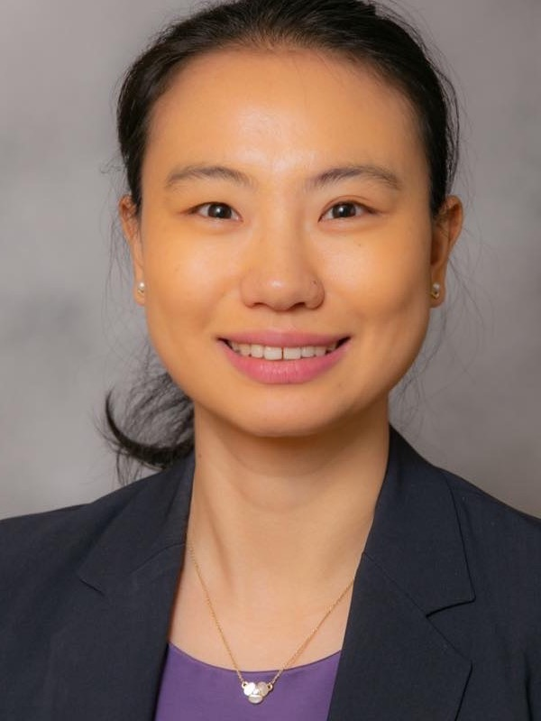

[Dr. Rong Wang](https://comm.uky.edu/people/wang)

Research Assistant; currently Assistant Professor, Department of Communication, University of Kentucky

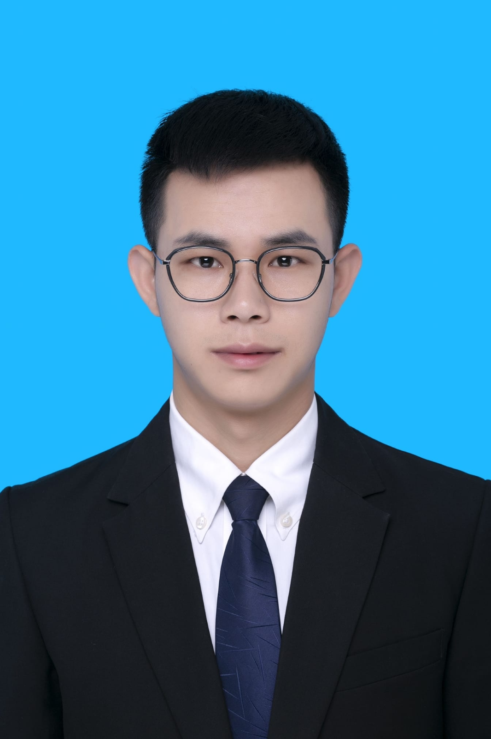

[Dr. Anfan Chen](https://www.researchgate.net/profile/Anfan-Chen)

Visiting PhD Student, Tsinghua University, 2019; currently PostDoc Researcher at **University of Science and Technology of China**

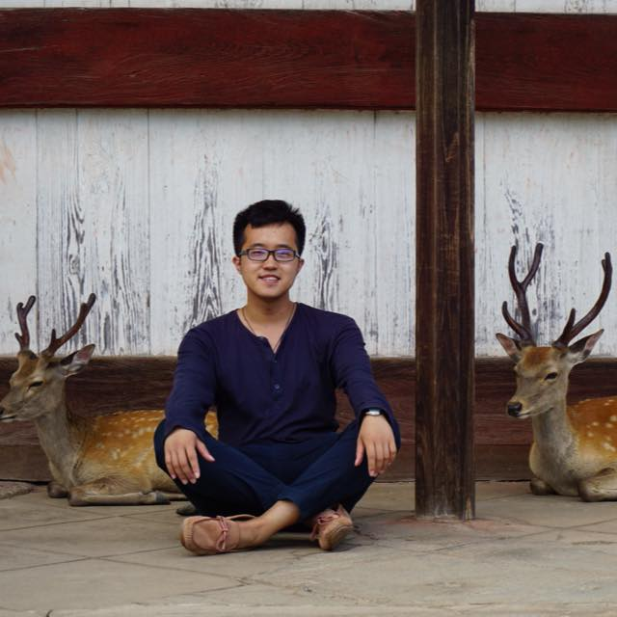

Zhuo Chen

Research Assistant, PhD Candidate



Yipeng Xi

Research Assistant, PhD Candidate

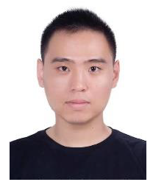

Tong Tong

Visiting PhD Student, Tsinghua University

Events

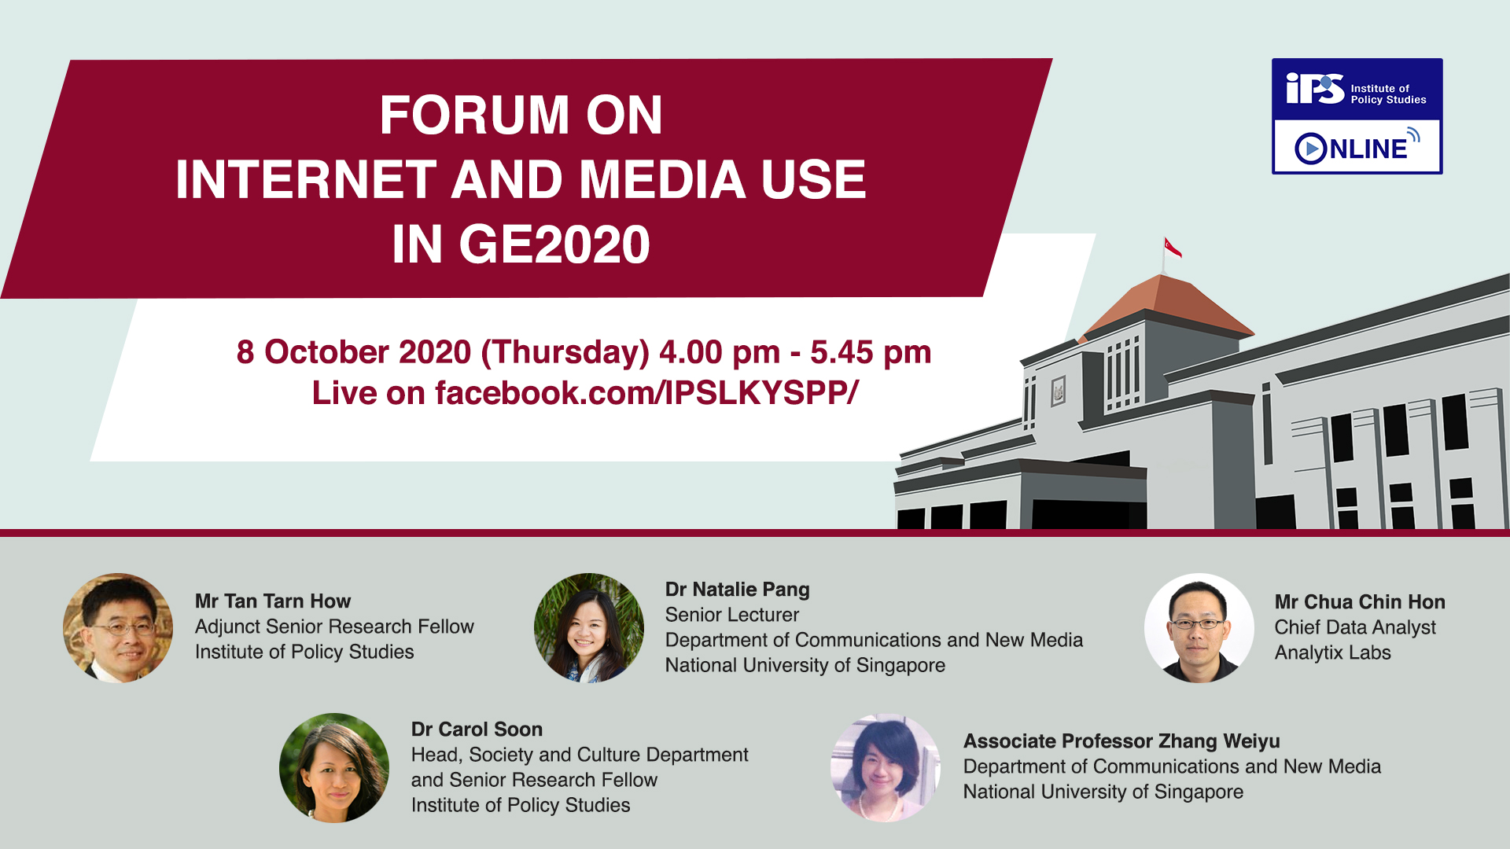

# [A forum on **Internet and Media Use in Singapore’s General Election 2020**](https://lkyspp.nus.edu.sg/ips/news/details/ips-online-forum-on-internet-and-media-use-in-general-election-2020) **was held online on** October 8th, 2020 **and open to the public. The research team was led by Dr. Carol Soon from Institute of Policy Studies, NUS. The study was reported and covered in local media:** [TodayOnline ,](https://www.todayonline.com/singapore/ips-post-ge2020-forum-older-voters-catch-digital-use-parties-missed-crucial-online-signals) [Channel News Asia,](https://www.channelnewsasia.com/news/singapore/ge2020-swing-voters-pap-opposition-party-ips-survey-13230088) [Mothership,](https://mothership.sg/2020/10/swing-voters-ge2020/) [Zaobao WeChat.](https://mp.weixin.qq.com/s/DSOOUADKhytd5c6ZfHTwHQ)

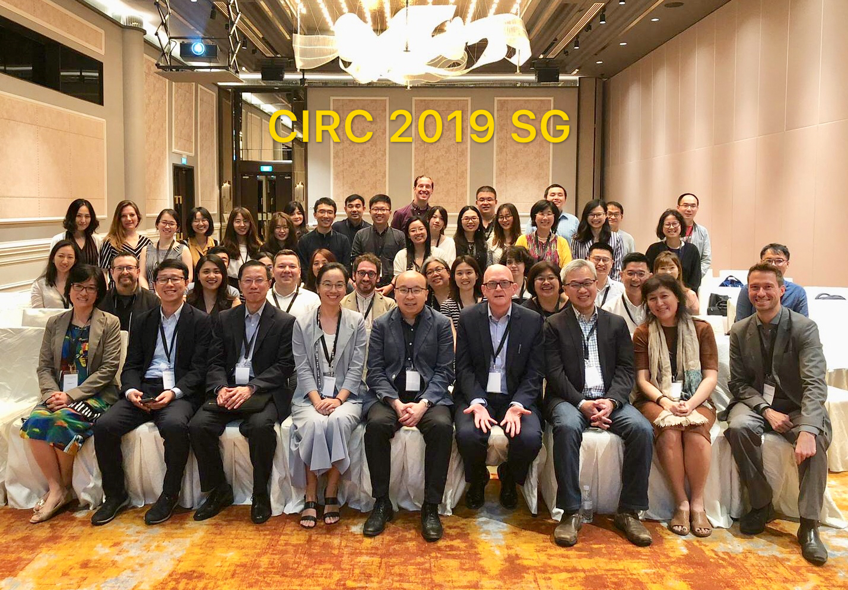

The 17th Chinese Internet Research Conference (CIRC) on “Digital Cultures: Chinese Internet and Beyond” was held on June 28, 2019 in Orchard Hotel Singapore. The conference was co-hosted by NUS and Murdoch University. More than 60 participants registered for this day long conference, including both academics and government officials. Researchers coming from all over the world (China, Australia, United Stated, Netherlands, Singapore, etc) made 29 presentations during the day. Two special issues, one in [*Global Media and China*](https://journals.sagepub.com/doi/full/10.1177/2059436420939322) (GMC) and one in [*Chinese Journal of Communication*](https://doi.org/10.1080/17544750.2020.1848405) (CJoC), have been published based on the conference submissions.

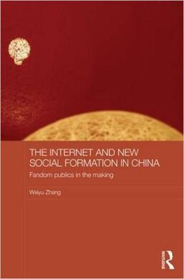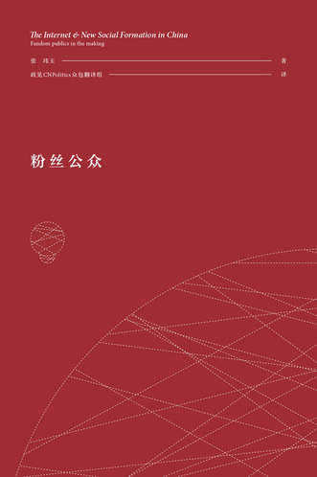

**An** [**interview**](https://www.asc.upenn.edu/news-events/news/annenberg-student-and-alumna-collaborate-crowdsource-book-translation) **with Penn Annenberg on the crowdsourced translation of the book "Fandom Publics in the Making" was published in May 2016. The translation project was a collaboration with the then Annenberg PhD student, and now Dr. Kecheng Fang.**

Publications

1. Xi, Y., Chen, A., & Zhang, W. (online first). T[he expression of cultural identities in Hong Kong’s Anti-Extradition Law Amendment Bill Movement: A semantic network analysis of tweets](http://dx.doi.org/10.1177/08944393211012267). *Social Science Computer Review.* [video]
2. Zhang, W., Chen, Z., & Xi, Y. (2021). [Traffic media: how algorithmic imaginations and practices change content production](https://doi.org/10.1080/17544750.2020.1830422). *Chinese Journal of Communication, 14(*1). 58-74. [video]
3. Zhang, W., & Neyazi, T. A. (2020). [Communication and technology theories from the South: the cases of China and India.](https://www.tandfonline.com/doi/pdf/10.1080/23808985.2019.1667852) *Annals of the International Communication Association, 44*(1), 34-49. [video]
4. Zhang, L. & Zhang, W. (2018). [The influence of monetization on the public functions of Weibo](https://www.weiyuzhang.net/uploads/2/2/2/7/222747/profits_or_public_interest_dilemma_in_the_business_of_weibo_togmc.pdf), *Global Media and China, 3*(3), 195-212.
5. Zhang, W. (2016). [Social media and elections in Singapore: comparing 2011 and 2015](https://www.weiyuzhang.net/uploads/2/2/2/7/222747/social_media_and_elections_2011_vs_2015_proof.pdf). *Chinese Journal of Communication, 9*(4), 367-384.
6. Zhang, W. & Sabrina, M. Anthony. (2016). Alternative tweeting: A comparison of frames in Twitter’s political discourse and mainstream newspaper coverage on Singapore General Elections 2011. In M. Adria & Y. Mao (Eds.), *Handbook of Research on Citizen Engagement and Public Participation in the Era of New Media*. IGI Global.
7. Zhang, W. (2016). [The Internet and New Social Formation in China: Fandom Publics in the Making](http://www.amazon.com/Internet-New-Social-Formation-China-ebook/dp/B01DBY49VC/ref=mt_kindle?_encoding=UTF8&me=). London and New York: Routledge. [[link to book website](https://www.weiyuzhang.net/fandom-publics.html)]
8. Zhang, W. & Pang, N. (2016). The Internet and social media. In Lee, T., & Tan, K. (Eds.), *Change in voting: Singapore’s 2015 General Election*. Singapore: Ethos Books.
9. Haciyakupoglu, G. & Zhang, W. (2015). [Social media and trust during the Gezi Protests in Turkey](http://onlinelibrary.wiley.com/doi/10.1111/jcc4.12121/full). *Journal of Computer Mediated Communication, 40*(2), 250-266.
10. Zhang, W. (2015). The silence of majority: Political talk during 2011 election time. In Tan, T. H., Mahizhnan, A., & Ang, P. H. (Eds.), *Battle for hearts and minds: New media and elections in Singapore*. pp.227-246. Singapore: World Scientific.
11. Zhang, W & Chib, A. (2014). [Internet studies and development discourses: The cases of China and India](https://www.weiyuzhang.net/uploads/2/2/2/7/222747/internet_studies_china_and_india_final_version.pdf). *Information Technology for Development, 20*(4), 324-338*.*
12. Zhang, W. (2014). [**新科技对政治传播的影响** The influence of new technologies on political communication](https://www.weiyuzhang.net/uploads/2/2/2/7/222747/forhong_draft_weiyu_zhang_2014.pdf) (**中文** in Chinese). In J. Hong (Ed.), *New trends in communication studies*. pp.732-746. Beijing, China: Tsinghua University Press.
13. Zhang, W. & Mao, C. (2013). [Fan activism sustained and challenged: Participatory culture in Chinese online translation communities](https://www.weiyuzhang.net/uploads/2/2/2/7/222747/fan_activism_final.pdf). *Chinese Journal of Communication, 6*(1), 45-61.
14. Zhang, W. (2012). [Virtual communities as subaltern public spheres: A theoretical development and an application to the Chinese Internet](https://www.weiyuzhang.net/uploads/2/2/2/7/222747/chapter_9_proof.pdf). In H. Li (Ed.), *Virtual community participation and motivation: Cross-disciplinary theories*. Pp.143-161. Hershey, PA: IGI Global.
15. Zhang, W. (2012). [The Effects of Political News Use, Political Discussion and Authoritarian Orientation on Political Participation: Evidences from Singapore and Taiwan](https://www.weiyuzhang.net/uploads/2/2/2/7/222747/political_news_use_political_discussion_and_authrotarianism_oct17.pdf). *Asian Journal of Communication, 22*(5): 474-492.
16. Zhang, W., & Wang, R. (2010). [Interest-oriented versus relationship-oriented social network sites in China](http://firstmonday.org/htbin/cgiwrap/bin/ojs/index.php/fm/article/view/2836/2582)*. First Monday, 15*(8).
17. Zhang, W. (2006). [Constructing and disseminating subaltern public discourses in China](http://javnost-thepublic.org/article/pdf/2006/2/3/). *Javnost-The Public, 13*(2), 41-64.

Presentations

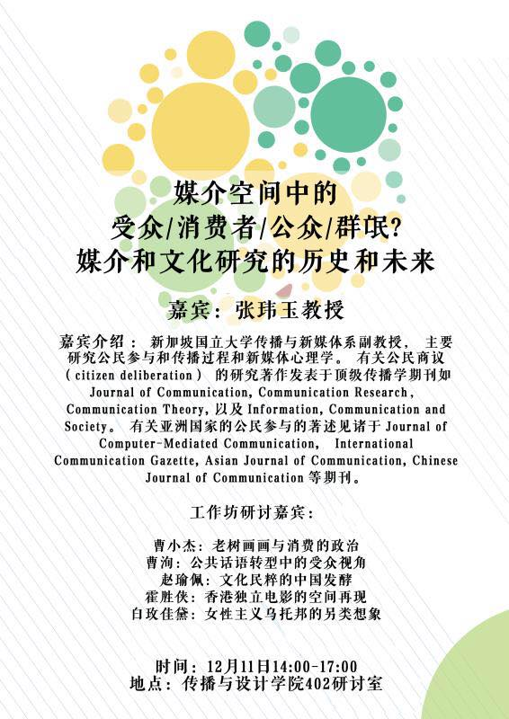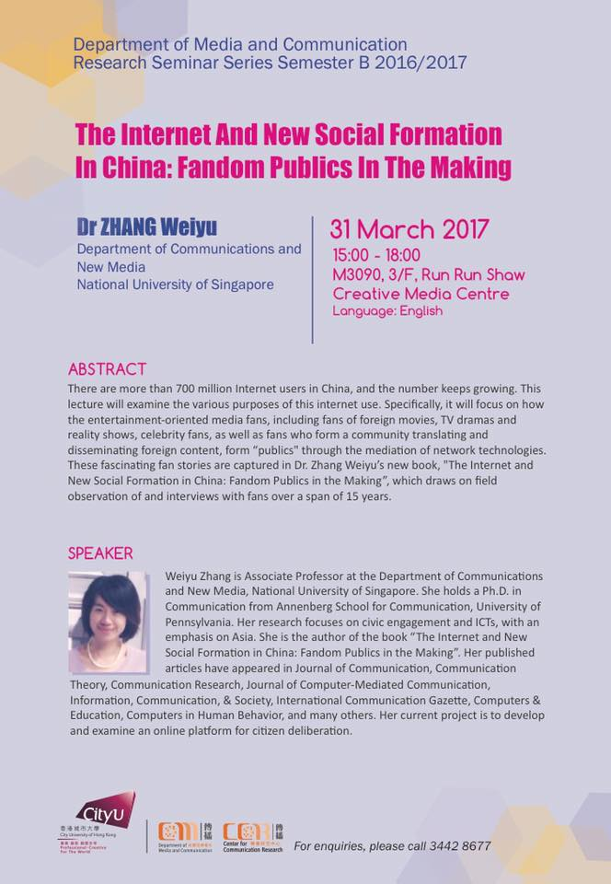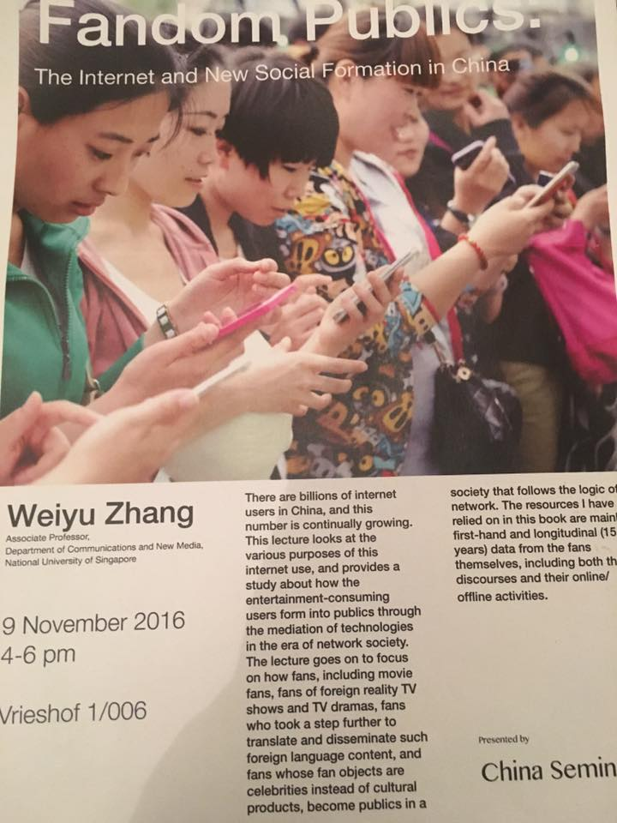

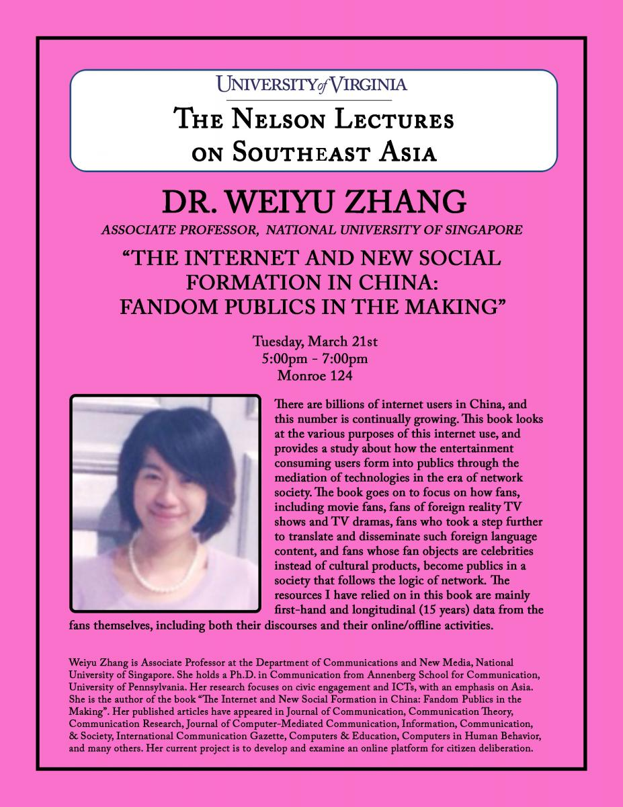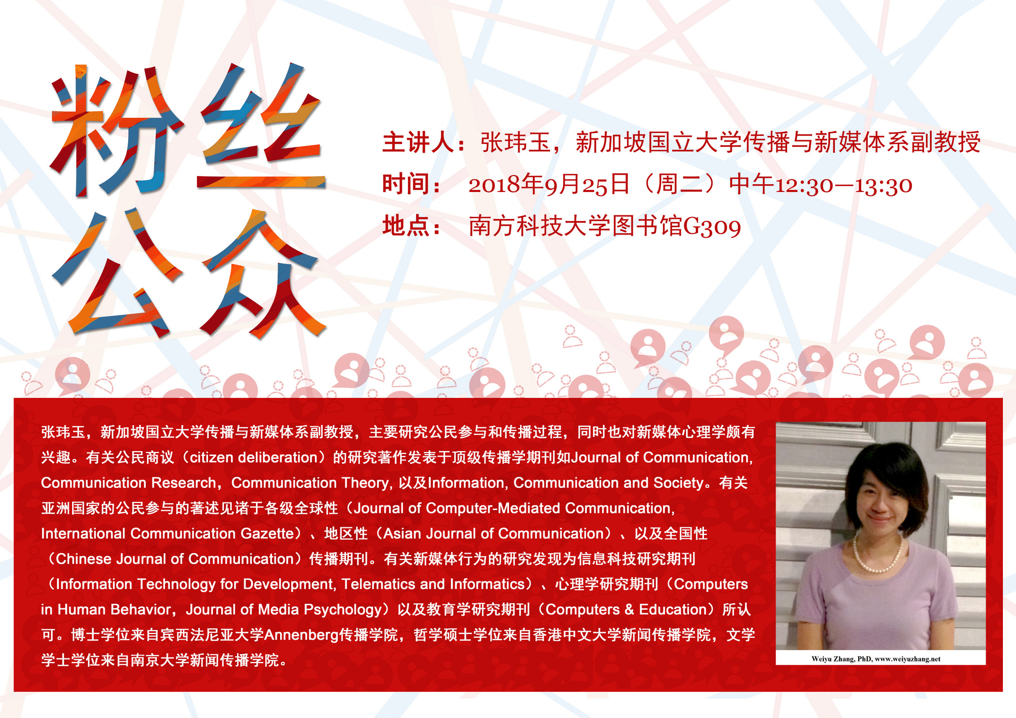

**A series of 9 book talks on "Fandom Publics in the Making" were made in either English or Chinese at various universities. [slides] 【演讲课件】**

* City University of Hong Kong, March 31st, 2017
* University of Virginia, March 21st, 2017
* Chinese University of Hong Kong, January 18th, 2017
* Leiden University, November 9th, 2016
* Royal Holloway University, September 20th, 2016
* 2019年9月24日 -- 广西艺术学院
* 2019年7月2日 -- 南京师范大学
* 2018年9月25日 -- 南方科技大学
* 2017年4月1日 -- 中山大学

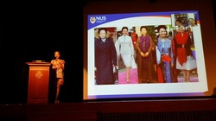

**A keynote speech on “celebrity activism on Weibo” was made at** Chinese Internet Research Conference (CIRC) **2014,** held at Hong Kong Polytech University. [slides]

**Partner Institutions**

This research was funded by AcRF Tier 1 Grant (R-124-000-095-115), NUS’ FASS Book Grant (R-124-000-066-133) and a series of research grants from Institute of Policy Studies led by Tan Tarn How and Dr. Carol Soon. Any opinions, findings and conclusions or recommendations expressed on this website are those of the authors and do not necessarily reflect the views of the funder.





